Visit Report: Bamna Upazila Health Complex, Barguna
Date of Visit: 24/08/22; Time: 9:45 AM.
Visitor: Md. Abdul Hakim Mazumdar, National Consultant (HEU),
Dr. Md. Emdadul Haque, National Consultant (HEU)
Md. Shamsur Rahman, Junior National Consultant (HEU) &
Dr. Nazmur Rahman Sajib, Junior National Consultant (HEU)
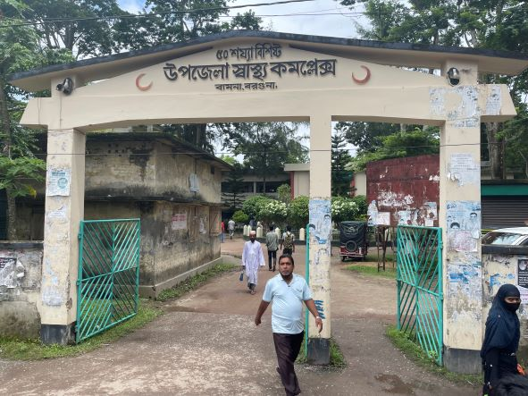
Fig-1: Front Gate of Bamna UHC
1. The infra-structure of this Upazila Health Complex is 50 bedded. The physical condition of the hospital building is good. The UHC is 37km. away from Civil Surgeon Office, Barguna. There are 4 unions under this UHC.
2. We arrived at 9:45 am in the health complex. But UH&FPO and all the medical officers were present in the health complex.
3. We met with the UH&FPO, RMO and other Medical Officers, discuss with them about the overall situation of the health complex. The post of Gynae and Anaesthesia consultant were vacant, so caesarean section is not being performed.
4. We visited outdoor of the Upazila Health Complex of Bamna. The outdoor was crowded with patients. We also observed Emergency, labour room, pathology and pharmacy department. The information display system was good but not updated. There was no effective health education system.
5. Cleanliness of the hospital premises and indoor was satisfactory. There is separate operation theatre having no equipment.
6. There is no cycle stand close to the main gate. There are many motorcycles parked within the premises.
7. The roof of the health complex is not clean. There are many bushes on the roof.
8. There spaces in emergency is congested. But SSK Booth and Pharmacy can be established close to the emergency department.
9. There are many “Danbox” throughout the UHC, and advised for removing those immediately.
10. There is a well decorated conference room in the UHC.
11. In 2021, OPD patient was 26,184 and indoor patient was 2,535; ANC 1st visit 72 and NVD was 39. Bed occupancy rate was 81.86% in 2021. As a whole, the institution is underutilized.
12. HSS score in July, 2022 was 279 among 423 UHC.

Health Profile of Bamna UHC, Bamna, Barguna
Total population: 94,036
Union: 4 Sub-centre: 0 FWC: 4 Community Clinic: 08
Human Resources: 50 Bedded Hospital:
Sl. | Designation | No. of Post | Present | Vacant
1. | UH&FPO | 1 | 1 | 0
2. | Junior Consultant | 11 | 0 | 11
3. | Medical Officer | 2 | 2 | 0
4. | Medical Officer (OSD) | 10 | 10 | 0
5. | Nurses | 21 | 20 | 01
6. | Mid wives | 04 | 04 | 0
7. | Medical Technologist (Lab) | 2 | 0 (1 deputed from other UHC) | 2
8. | MT EPI | 1 | 1 | 0
9. | Dental Technologist | 1 | 0
10. | MT (Radiology) | 1 | 0
11. | SACMO | 3 | 3
12. | Health Inspector (HI) | 1 | 1
13. | Assist. Health Inspector | 4 | 4
14. | Health Assistant | 18 | 18
15. | CHCP | 09 | 08
16 | Head Assistant | 01 | 0 | 1deputed
18. | Accountant/Statistician | 2 | 1(No accountant) | 1
19. | MLSS | 4 | 2 | 2
20. | Cleaner | 5 | 2 | 3
21. | Guard | 02 | 01 | 01
22. | FWA
23. | Outsourcing: Driver | 01 | 01 | 0

Status in HSS Score From Jan-July:
Name | Janu | Feb | Mar | April | May | June | July
Barguna D-Hospital | 03 | 07 | 19 | 22 | 21 | 16 | 19
Amtoli UHC | 319 | 200 | 255 | 298 | 207 | 368 | 353
Betagi UHC | 306 | 314 | 304 | 332 | 340 | 337 | 341
Bamna UHC | 221 | 162 | 290 | 230 | 279 | 277 | 279
Pathorghata UHC | 209 | 291 | 347 | 258 | 248 | 270 | 385
Taltoli UHC | - | - | - | - | - | - | -

Status of Building Blocks of C-J Model in the Bamna UHC:
Sl | Criteria of C-J Model | Best | Good | Weak
01 | Cycle stand close to the main gate |  |  | √
02 | Health Education |  |  | √
03 | Cleanliness & beautification |  | √
04 | Separation of patients in out door & indoor |  |  | √
05 | Blood doner list with 24/7 B.T facility |  | √
06 | Birth- death recording |  |  | √
07 | Reception Desk |  |  | √
08 | Developed Emergency Dept. |  | √
09 | 5S –KAIZEN implementation. |  |  | √
10 | Community Participation. |  | √
11 | Hospital activities Display |  |  | √
12 | Corner based service. |  | √
13 | Cash counter for receiving Govt money. |  |  | √
14 | Devolped maternal health/labour word. |  |  | √
15 | Devolped paediatric health |  |  | √
16 | Position in HSS score in July22.  (Best= <100; Good= 101-200; Weak= >200) |  |  | √
17 | Power point Presentation &Video on UHC |  |  | √
18 | Knowledge about 8th Five Year plan & SDG. |  |  | √
19 | Zero-Tollarance on corruption |  | √

Recommendations:
1. For better office management, the post of Head Assistant and Accountant is very important. Both the post are lying vacant. It should be filled up immediately.
2. Cleanliness and beautification is satisfactory. The local Powroshova must take part in waste management.
3. There should be funtioning OT room for major operation in the health complex.
4. Labor room is functioning.
5. Condemetion Board should work to destory all unwanted items.
6. All the vacant posts of 4th class should be fulfilled immediately.
7. Medical Technologist (Dental), Medical Technologist (Radiology), Cardiographer post must be fullfilled.
8. Replication of C-J model will help in development of the quality of care and it should be followed properly.
11. All the post of consultants specially Gynae consultant and Anesthesia should be filled up immediately .
12. Radiogical service is functioning by local arrangement.Vaccant post of radiographer should be fulfilled.
14. There should be a Complaints and Suggestion box in front of UH&FPO room
15. The roof of the health complex building should be cleaned.
16. There should be availability of safe drinking water.
17. All the “Danbox” of the UHC, should be remove.

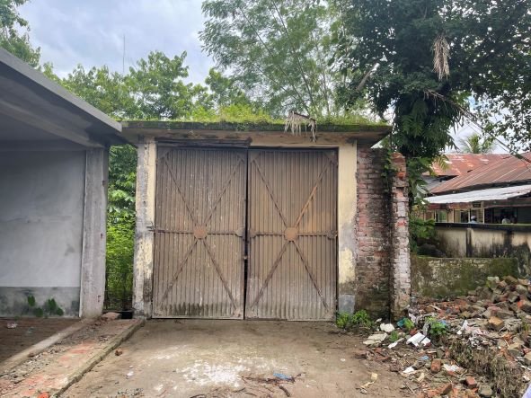
Fig-2: Unclean garage roof inside UHC

Fig-3: Proposed Cycle stand area for UHC

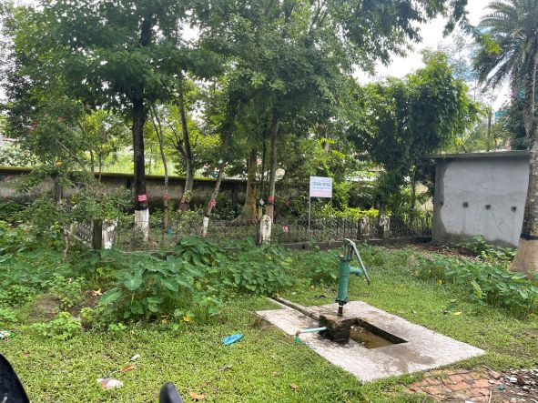
Fig-4: Unused signboard inside UHC

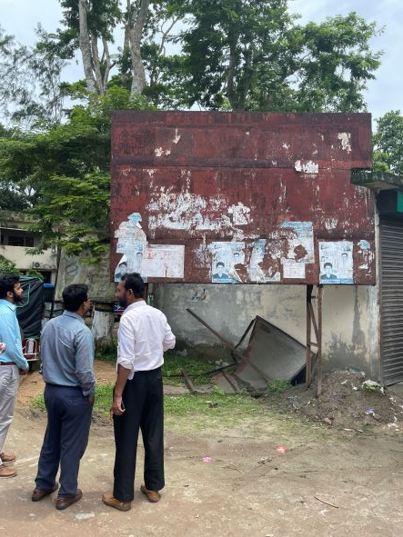

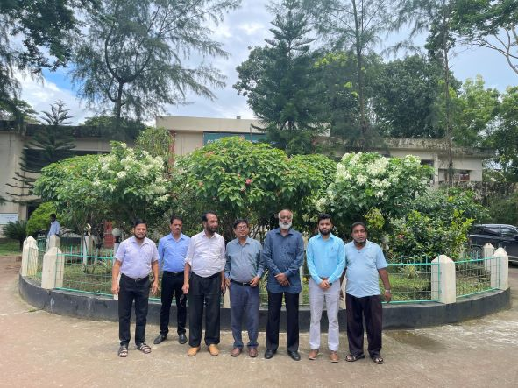
Fig-5: Beautiful garden in the UHC compound

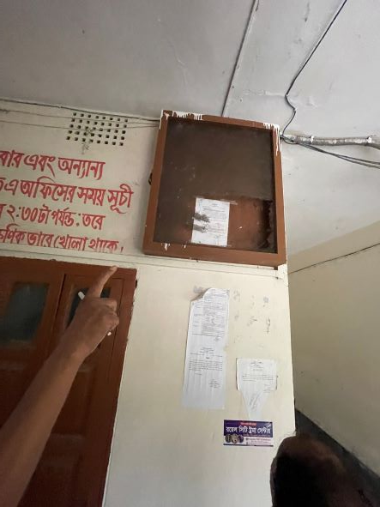
Fig-6: Unused display board due to inappropriate setup

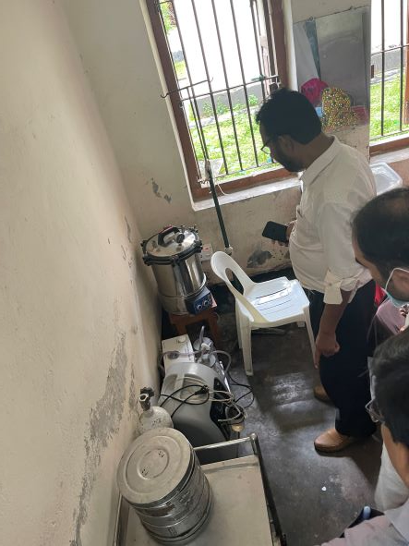
Fig-7: Functional sterilizer, oxygen condenser in emergency room

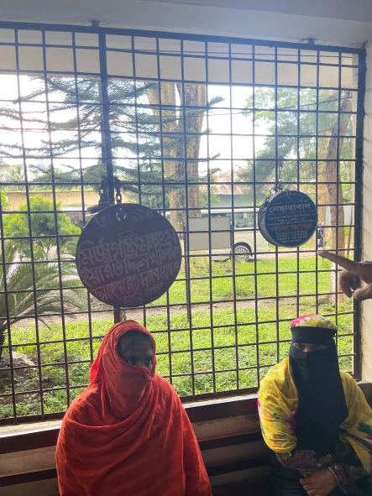
Fig-8: Danbox in hospital corridor

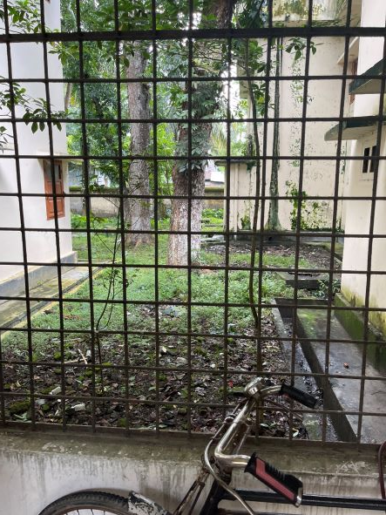
Fig-9: unclean area beside health complex corridor

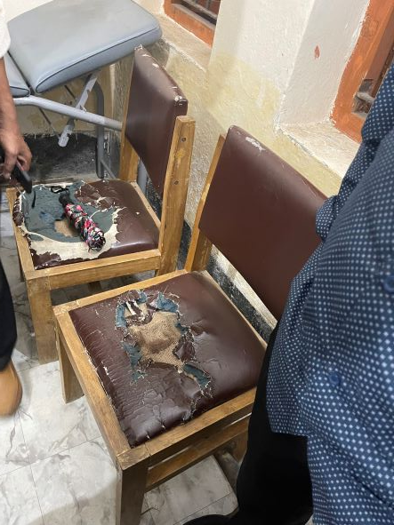
Fig-10: Unusable chair in doctors room

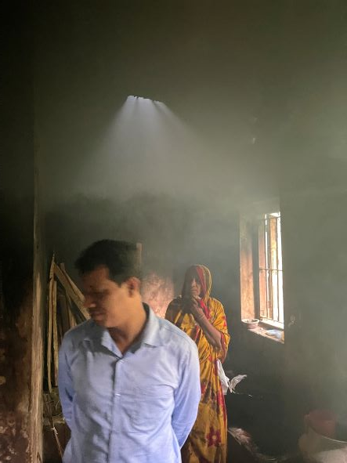
Fig-11: Nonfunctional exhaust fan in the kitchen

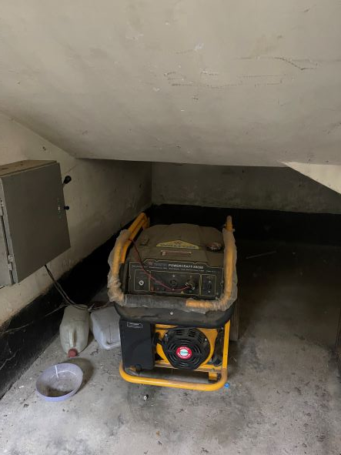
Fig-12: Functional generator donated by Upazila Porishod

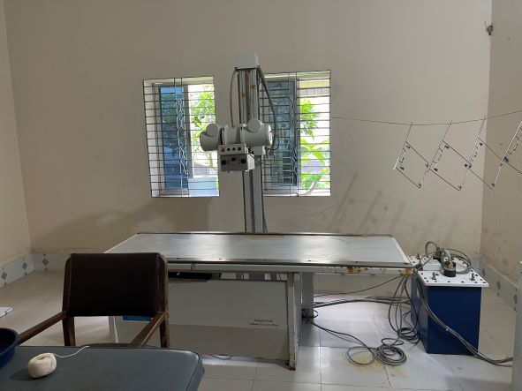
Fig-13: Functional X-ray facility in UHC

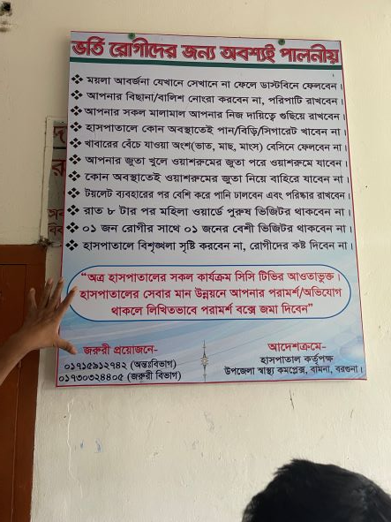
Fig-14: Instructions for patients and attendants (good practice)

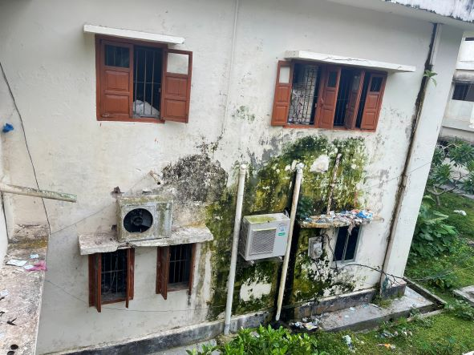
Fig-15: Unclean wall and shades of UHC building

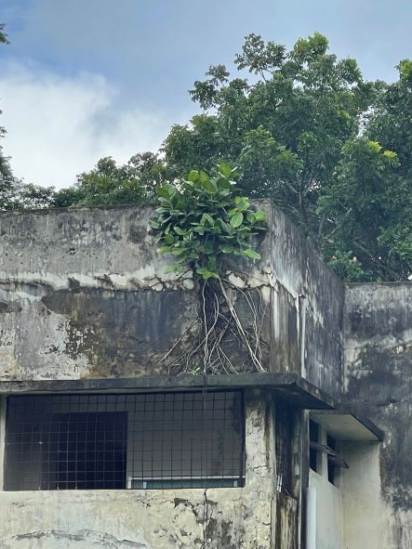
Fig-15: Unclean Building roof filled with shrubs

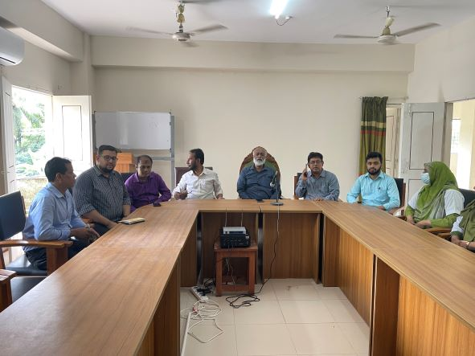
Fig-16: Beautiful conference room

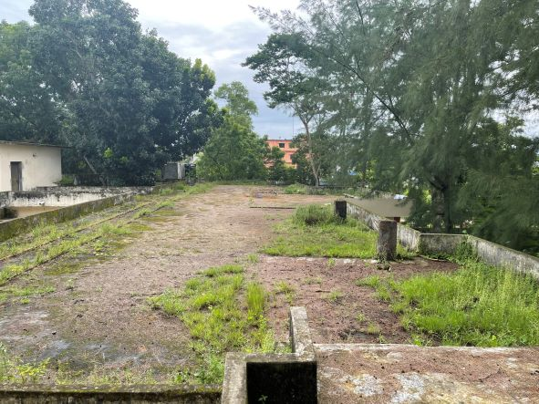
Fig-17: Unclean Building roof filled with shrubs

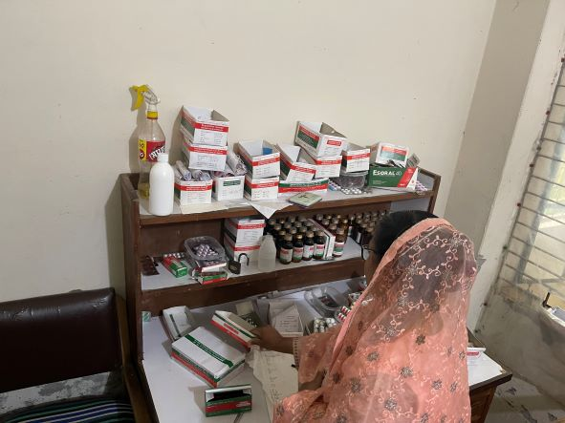
Fig-18: Pharmacy of UHC (disorganized)

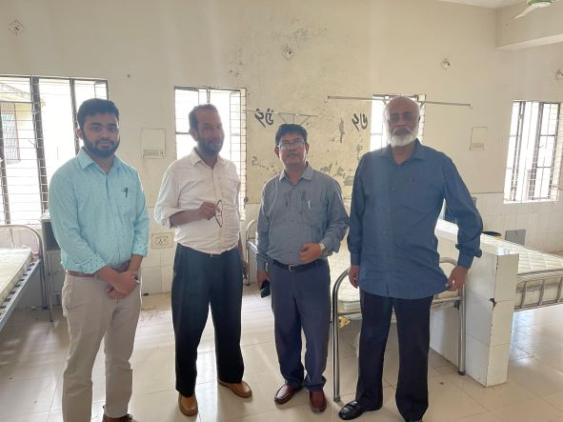
Fig-19: Proposed paediatric ward for UHC

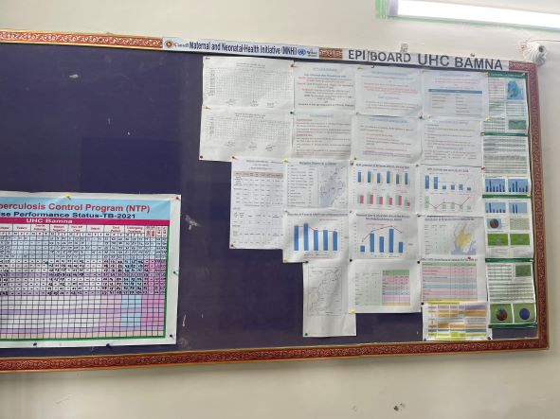
Fig-20: Improved display system, needs to be updated

